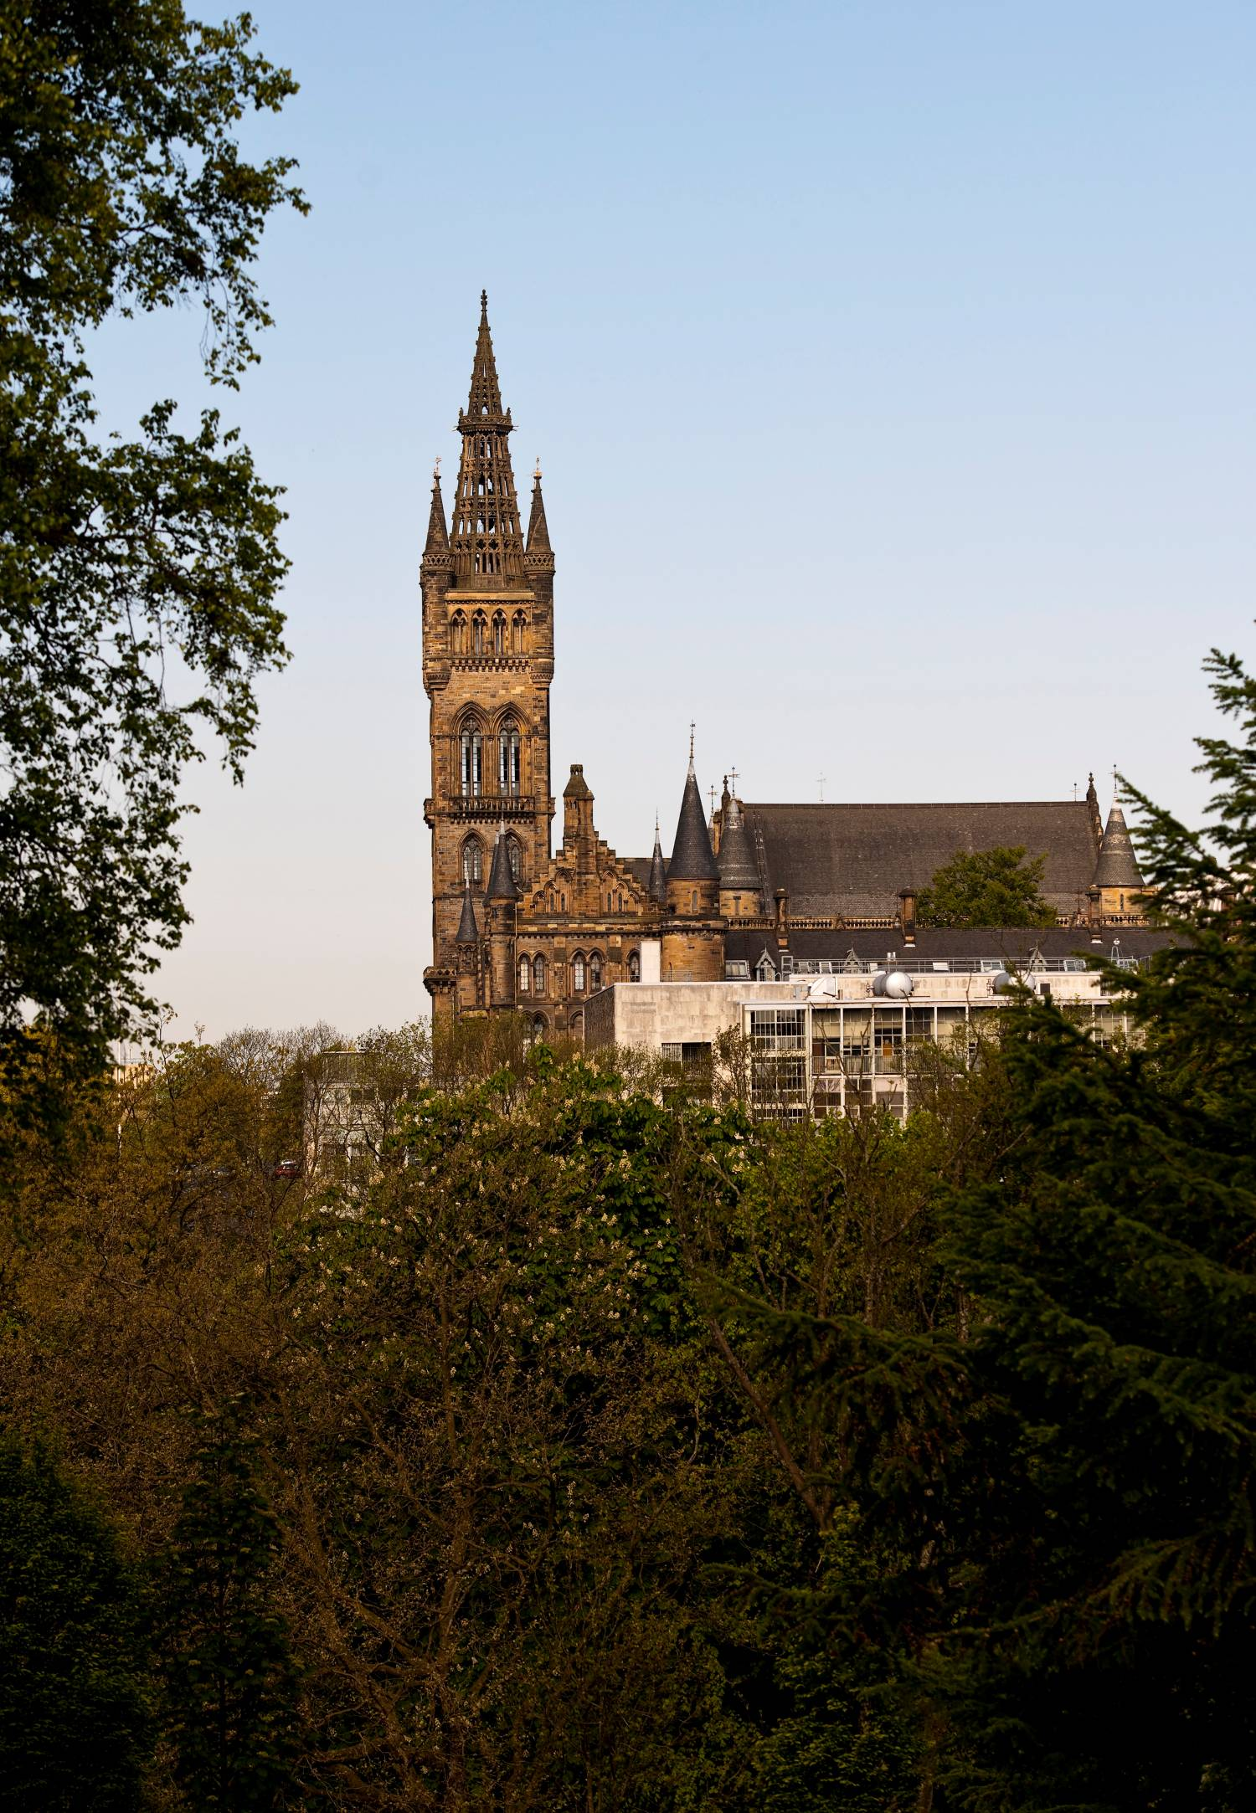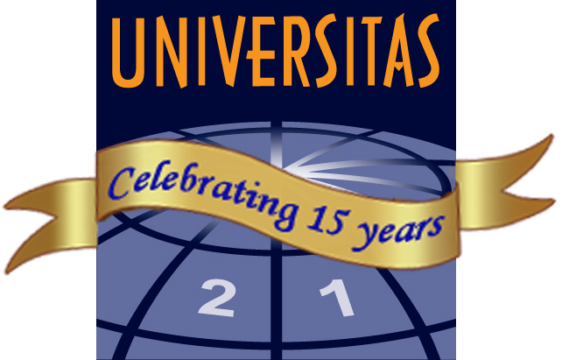
Lifelong learning driving universities’ ambitions? Dare we? Can we? Let’s!
14-15TH MAY 2012
University of Glasgow, charity number SC004401
U21 LIFELONG LEARNING WORKSHOP

UNIVERSITY OF GLASGOW MAP
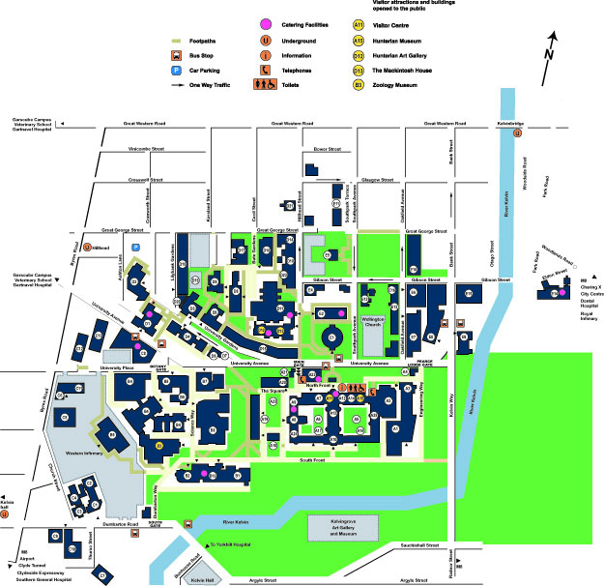

Welcome to U21 Lifelong Learning Workshop:
‘Lifelong learning driving universities’ ambitions? Dare we? Can we? Let’s!’

This workshop will offer an opportunity to explore, and claim for outreach in the form of adult education and lifelong learning, a prominent role in research intensive universities. We will identify ways that reaching out into regional and international communities contributes to our institutions’ core activities and we will explore how, having established the strategic relevance of our work, activity can best be delivered.

Participants should be willing to flex, to respond to emerging trends and to seek alignment between outreach and the goals and missions of their institutions.

A series of sessions will be held, each will begin with a short contextualising presentation followed by a round table discussion. Each session will address how outreach activities can drive universities’ ambitions in strategically critical areas.

The workshop includes a final session dedicated to informal collaboration during which participants will take the ideas generated within the workshop and develop individual strategies and plans to take home to their own institutions.

Professor Susan Geerthuis, University of Auckland
Professor Mike Osborne, University of Glasgow
May 2012
PROGRAMME OF EVENTS

Monday 14 May 2012

1000 | Registration and introductions  Coffee/tea available
1030 | Welcome  David Newall, University Secretary, University of Glasgow
1045 | Scoping the problem  Susan Geerthuis, University of Auckland  Research intensive institutions are unlike their regional counterparts, whilst being committed to regional engagement they operate in a global arena. The strategic ambitions of all our institutions are likely to include: lifting the institution’s international profile, attracting diverse and able students, contributing to the local economy and building revenue. In this short session we will consider how lifelong learning activities in our home universities align, or perhaps at times, run counter to these ambitions. We will consider the strategic, organisational and financial barriers that we face.
1145 | Workshop 1: Enriching the student body  Facilitator: Mike Osborne, University of Glasgow  In this session techniques and success stories will be shared. Three short case studies from different U21 universities will be described by other participants. Each case will illustrate how lifelong learning educators successfully brought adults into university degree programmes. We will workshop key success criteria for lifelong learning initiatives designed to bring diverse younger and older adults into and through prestigious universities.  Cases:  Glasgow: Alex Mackinnon and Kevin Francis  Monterrey: Martha Del Angel  Queensland: Michael Cuthill
1300 | Lunch
1400 | Workshop 2  Building entrepreneurship and innovation  Facilitators: Josef Konvitz, former Head, Urban Affairs and Regulatory Policy Divisions, OECD  James Powell, UK Ambassador for Social Enterprise in Higher Education  In this session we will consider firstly how our universities seek to promote innovation in their students and staff and how they interface with their regions. The workshop will continue by brainstorming and assessing how lifelong learning opportunities can/could contribute to and supplement these activities.
1530 | Afternoon Tea
1600 | First thoughts on improved strategic directions  Facilitator: Mike Osborne, University of Glasgow  Mike will capture ideas generated during the day, in an effort to isolate strategies at university or department level that would drive innovation, entrepreneurship and/or lift the potential and diversity of the student body.
1700 | Close

Tuesday 15 May 2012

0915 | Welcome and Coffee
0930 | Workshop 3: Dissemination and high impact research  Facilitator: James Conroy, University of Glasgow and member of the UK Research Excellence Framework (REF) panel for Education  Jim will discuss the importance of research impact to funding bodies. He will outline recent thinking on the ways academics can engage with their regions in an effort to raise awareness of their research. Participants will consider their current and potential contribution through lifelong learning activities to the drive for high impact research.
1100 | Coffee
1130 | Workshop 4: Creating a national and global reputation through outreach  Facilitator: Sid Katz, University of British Columbia  Two potential mechanisms for profile raising are the use of media and university collaboration in global events. Sid Katz will lead this session talking both about his approaches to capitalising on major events and his use of national media to build the reputation of his institution. Further examples and approaches will be offered by Anthony Davis (University of Technology, Kingston) and Olesya Nedvetskaya from Siberia in Russia who are researching how universities can demonstrate their relevance and capabilities through partnering in major sporting events.  John Tibbitt from the University of Glasgow will similarly enrich this session by demonstrating how technologies can be used to supplement traditional media in providing access to universities’ thinking and so serve to build national and international reputation.  Through discussion participants will identify mechanisms for advancing their own institutions.
1300 | Lunch
1400 | Workshop 5: The business of Lifelong Learning – strategic, organisational and financial considerations  Facilitator: Susan Geerthuis, University of Auckland  Susan Geertshuis will briefly introduce strategic approaches, organizational dilemmas and the issue of revenue. This is the session when participants really get to work, taking their own university or departmental strategies and plans as a starting point an effort will be made to identify a number of short term ‘easy wins’ and achievable longer term strategies that remove barriers or enhance activity and so lift the contribution of lifelong learning and outreach to universities overall success. The facilitators will introduce a number of thinking and planning tools to help participants analyse and plan.
1600 | Congratulations, thanks and close
1630 | Participants leave equipped to contribute fully to their universities’ ambitions to attract a talented student body, deliver high impact research, develop a global reputation for excellence and achieve a sustainable model of delivery!

DELEGATE LIST

NAME | DEPARTMENT/TITLE | UNIVERSITY
Birrell, Tom | Executive Officer (Arts and Science), Centre for Lifelong Learning | University of Aberdeen
Bradley, Jim | Director of Access, School of Education | University of Stirling
Campbell, Jim | School of Education | University of Glasgow
Clancy, Sharon | Head of Community Partnerships | University of Nottingham
Cuthill, Michael | Chair, Regional Community Development | University of Southern Queensland
Davis, Anthony | Director, Department of Sport | University of Technology, Kingston, Jamaica
Del Angel, Martha | School of Humanities and Social Sciences | Tecnológico de Monterrey, Mexico
Duke, Chris | Honorary Professor, Social Sciences and Planning | RMIT, Australia
Fleming, Bairbre | UCD Adult Education | University College Dublin
Foster, Alan | Research centre manager, School of Education | University of Glasgow
Francis, Kevin | University Teacher in Access, School of Education | University of Glasgow
Geerthuis, Susan | Head of Centre for Continuing Education | University of Auckland
Gilmour, Alan | Executive Officer, LEaRN | University of Melbourne
Hamilton, Robert | Senior Lecturer, Social Justice Place and Lifelong Education | University of Glasgow
Hammond, Keith | Lecturer, Social Justice Place and Lifelong Education | University of Glasgow
Herrick, Tim | Director of Learning and teaching Enhancement | University of Sheffield
Houston, Muir | Lecturer, Social Justice Place and Lifelong Education | University of Glasgow
Innes, Paul | Senior Lecturer, Creativity, Culture and Faith | University of Glasgow
Jordan, Lynette | Lecturer, Social Justice Place and Lifelong Education | University of Glasgow
Kamando, Amina | Lecturer in Education | University of Dar es Salaam
Katz, Sid | Professor, formerly Executive Director UBC Community Affairs and Managing Director, Chan Centre for the Performing Arts | University of British Colombia
Kelly, Anna | Director of Access and Lifelong Learning | University College Dublin
Kitchen, Willy | Director of Learning and Teaching, Institute for Lifelong Learning | University of Sheffield
Konvitz, Josef | Honorary Professor, School of Education | University of Glasgow
Laitinen, Ilpo | Professor of Public Sector Innovation | University of Jyvaskyla, Finland
MacKinnon, Alex | Interdisciplinary Science Education Technologies and Learning | University of Glasgow
Maclellan, Effie |  | University of Glasgow
Maguire, Kate | Institute for Work based learning | Middlesex University
Maitland, Ian | Education Guidance | University of the West of Scotland
Mark, Rob | Head of Centre for Lifelong Learning | University of Strathclyde
Molosi, Keneilwe | Lecturer in Adult Education | University of Botswana
Mwaikokesya, Mpoki | Lecturer in Adult Education | University of Dar es Salaam
Newall, David | Secretary of Court | University of Glasgow
Osborne, Mike | Chair of Adult and Lifelong Learning | University of Glasgow
Pan, Yi-Chen | PhD Student | University of Edinburgh

DELEGATE LIST (CONTINUED)

Park, Maureen | Lecturer, Social Justice Place and Lifelong Education | University of Glasgow
Powell, James | PASCAL | University of Glasgow
Richardson, Mark | Centre for Community and Lifelong Learning | University of Wales
Robinson, Claire | PhD student/Public Engagement Ambassador | University of Birmingham/  National Coordinating Centre for Public Engagement, UWE
Stenvall, Jari | Professor in Administrative Studies | University of Lapland
Taylor, John | Professor, Management School | University of Liverpool
Tibbitt, John | Honorary Research Fellow, School of Education; PASCAL | University of Glasgow
Ward, Sarah | U21 Coordinator | University of Glasgow
Watt, Hazel |  | University of Cumbria
Webster, Elaine | Director, Summer School & Continuing Education | University of Otago
Welch, Dorothy | Deputy Secretary, Court Office | University of Glasgow
Wynne, Rhonda | UCD Adult Education | University College Dublin

NOTES

